**What is HTTP?**

Is Hypertext Transfer Protocol (HTTP) of the World Wide Web, and is used to load webpages using hypertext links. HTTP is an application layer protocol designed to transfer information between networked devices and runs on top of other layers of the network protocol stack.

**Version of HTTP?**

HTTP has four versions.

* HTTP/0.9
* HTTP/1.0
* HTTP/1.1
* HTTP/2.0

**HTTP1.1:**

* This document outlines Internet standards track protocol for the Internet community and invites feedback and discussion on how to make it better.
* In this process, a client sends a text-based request to a server by calling a method like **GET** or **POST.**
* In response, the server sends a resource like an HTML page back to the client.

For example,

GET /index.html HTTP/1.1

Host: [www.example.com](http://www.example.com)

**HTTP2:**

It is a binary protocol that allows the multiplexing of multiple parallel requests over a single TCP connection, resulting in fewer TCP connections overall.

**HTTP/2 — Advantages of the Binary Framing Layer**

* As opposed to HTTP/1.1, which must make use of multiple TCP connections to lessen the effect of HOL blocking, HTTP/2 establishes a single connection object between the two machines.
* Within this connection there are multiple streams of data.
* Each stream consists of multiple messages in the familiar request/response format

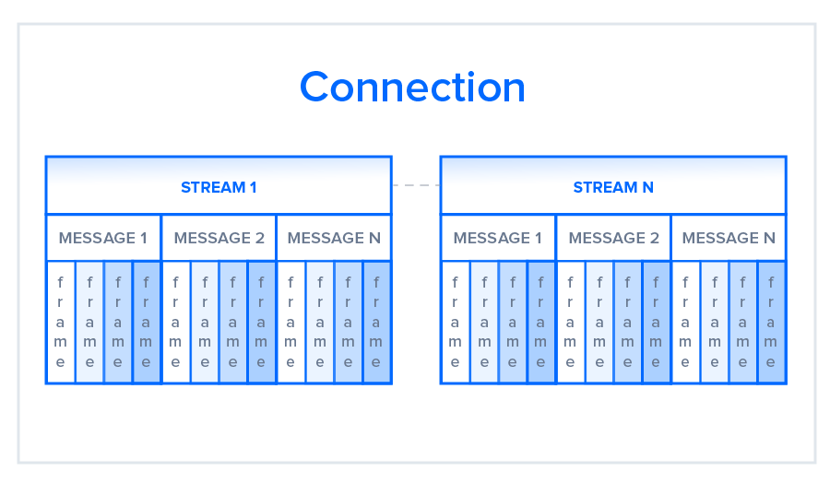

**Differences between HTTP 1.1 vs HTTP 2:**

|  |  |
| --- | --- |
| HTTP/1.1 | HTTP/2 |
| It works on the textual format. | It works on the binary protocol. |
| There is head of line blocking that blocks all the requests behind it until it doesn’t get its all resources. | It allows multiplexing so one TCP connection is required for multiple requests. |
| It uses requests resource Inlining for use getting multiple pages | It uses PUSH frame by server that collects all multiple pages |
| It compresses data by itself. | It uses HPACK for data compression. |

